Final Project #1 by Joshua Troup

1. Find the customer with the highest profit. What is the customer’s (with highest profit) average shipping cost per order? (Include numerical values in your response)

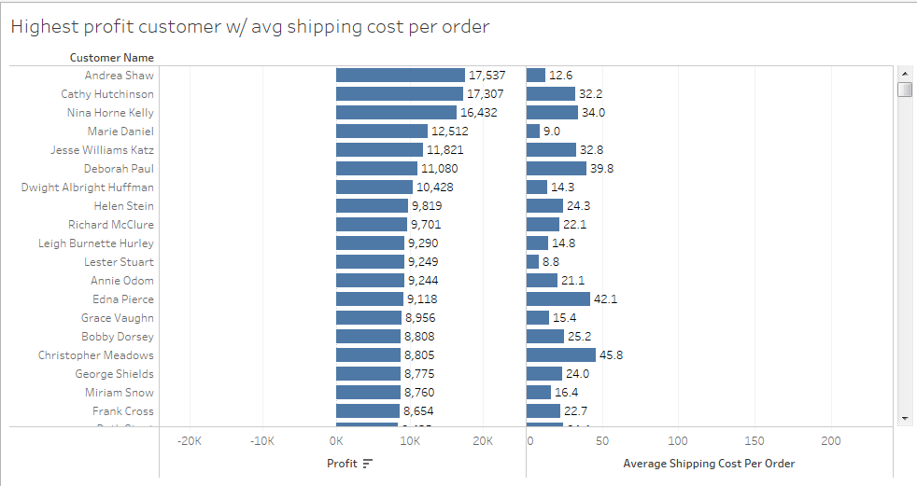

**Andrea Shaw has the highest profit of $17,537 with a $12.6 average shipping cost per order.**

1. Which Product (Furniture, Technology, Office Supplies) has the largest Interquantile Range (IQR) for Sales?

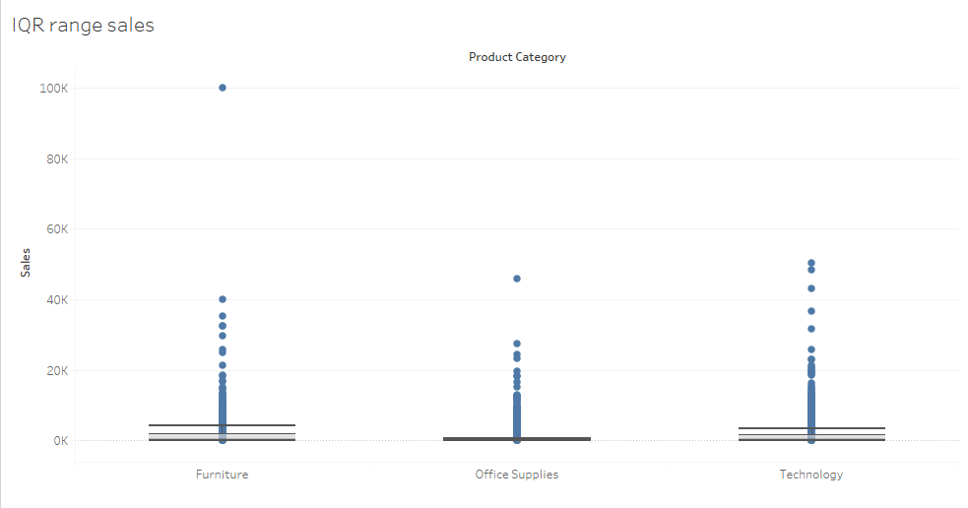

**Furniture = 1804-167 = 1637**

**Office Supplies= 283-39 = 244**

**Technology= 1505-207 = 1298**

**Furniture has the largest IQR range.**

1. Which Product Sub category has total sales which is $81,960 below the average sales per sub-category?

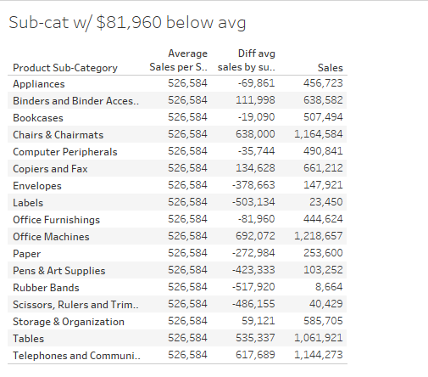

**Office Furnishings**

1. Find the top three products ordered in the greatest quantities. Name the Top 3 cities with Positive Profit for the Top 3 products ordered.

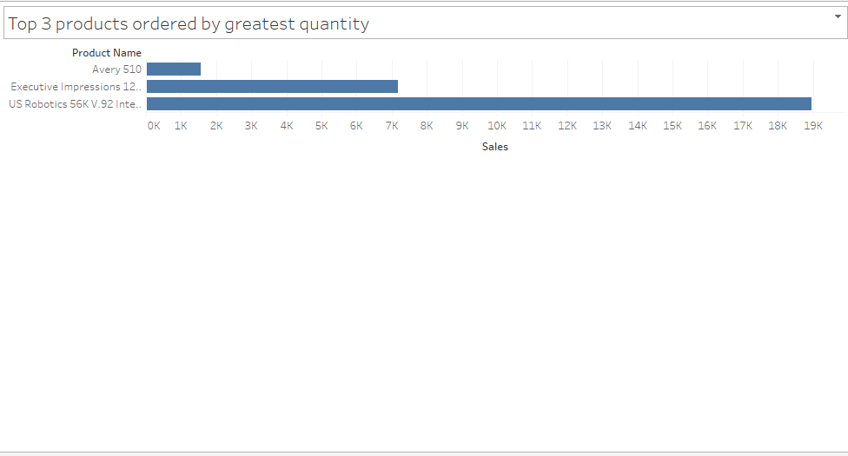

1. **Avery 510 – 1,555 sales**
2. **Executive Impressions – 7,175 sales**
3. **US Robotics – 18,954 sales**

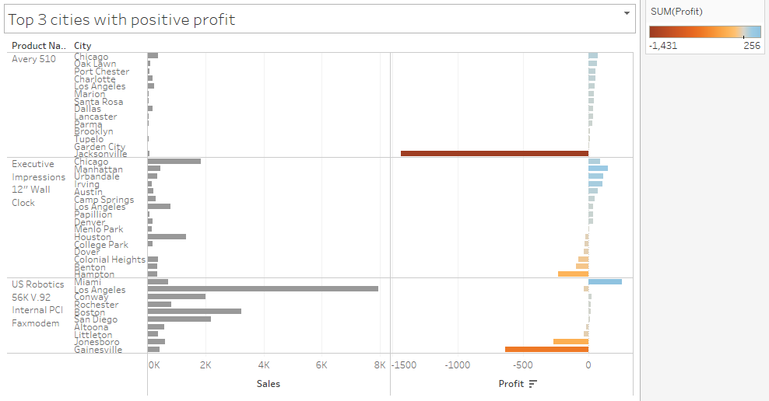

**Miami-256**

**Manhattan-149**

**Urbandale-113**

1. Find the total number of Small Business Customers placing orders from the Superstore. Are Small Business Customers placing the highest # of orders? If not, which type of customers have placed the highest number of orders and how many?

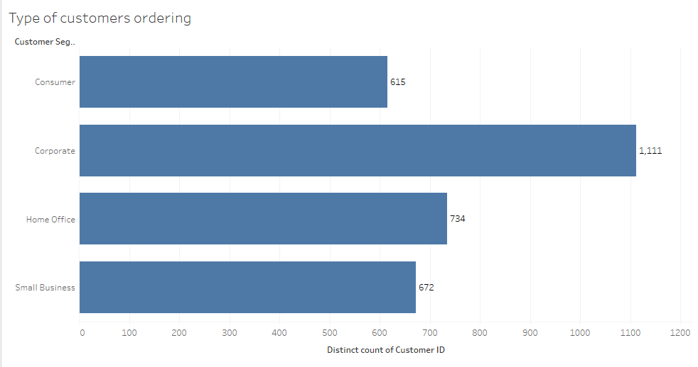

**672 small business customers placed orders from the Superstore. Corporate customers have placed the greatest amount of orders from the Superstore.**

1. Find the Total Profit for the South Region for items ordered in 2013.

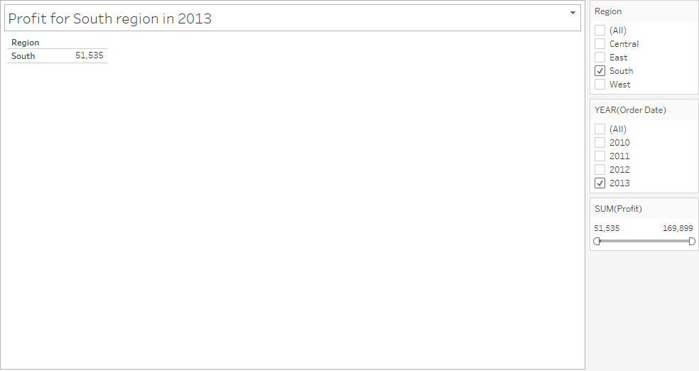

**Total profit in the South region in 2013 - $51,535**

1. Which Product sub-category has the Highest ratio of Profit to Sales?

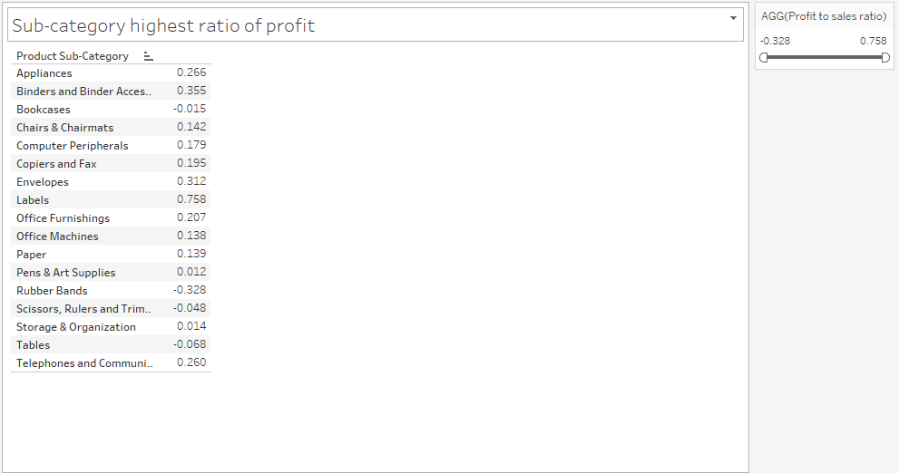

**Labels has the highest ratio of profit to sales with a value of .758**

1. Create a Linear Trend Line using Shipping Cost to predict Unit Price. What % of variance in the Unit Price is explained by the Linear Model? Answer must the % number.

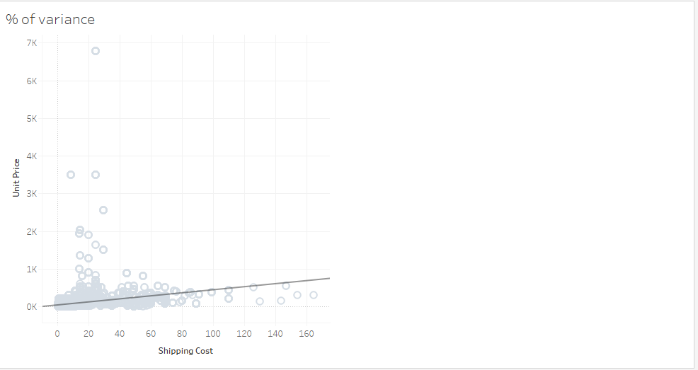

**The percentage of variance in the unit price is .0606394 or 6%.**

1. Build a Scatter Plot with Sales (X Axis) and Shipping Cost (Y Axis). Add a Linear Trend Line. From the equation for the trend line, for each additional dollar of Sales, the Shipping Cost increases by an average of what amount?

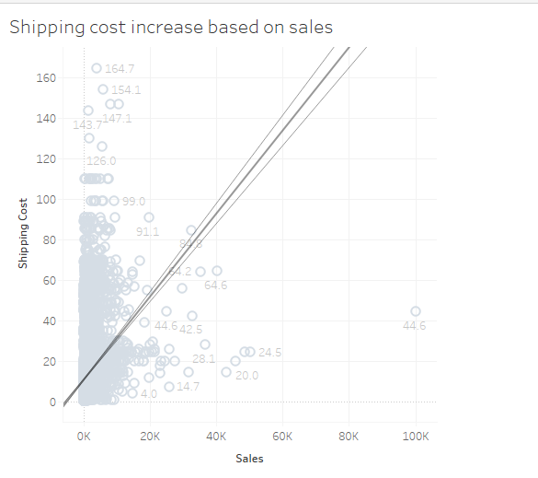

**The shipping cost increases by an average of $.002.**

1. Create a Trend Line for Profit Vs Sales. Based on the R Squared value, which model is the Best Fit?

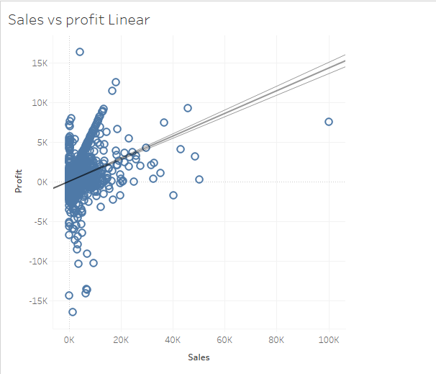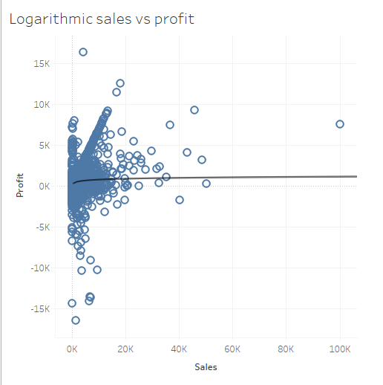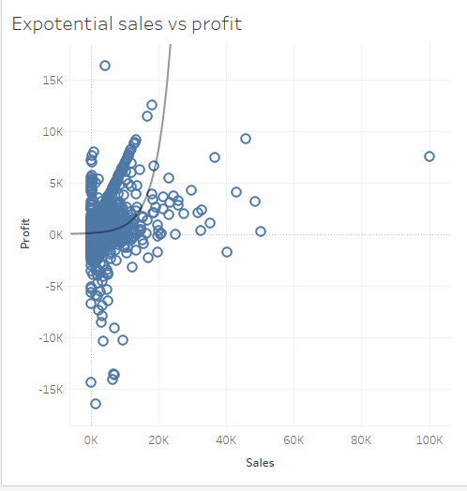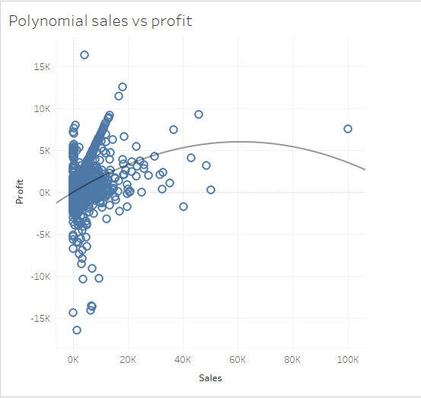

**Polynomial trend line is the best model with the best fit or highest R squared value of .156299.**